Chapter 16, Solution 88.

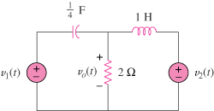

First select the inductor current i_{L} (current flowing left to right) and the capacitor voltage v_{C} (voltage positive on the left and negative on the right) to be the state variables.

Applying KCL we get:

